

Peer Tutoring Platform
Specification Report

Due before 5pm 24/04/2026
South East Technological University Carlow

Written By
Student Name: Temur Rustamov
Student Number: C00280204
Student Email: C00280204@setu.ie

Supervised By
Lecturer Name: Jamal Tauseef
Email: Jamal.Tauseef@setu.ie

Table of Contents
1. Introduction 3
1.1 Background 3
1.2 Problem Statement 3
2. Project Goal 4
3. User Groups 4
4. Functional Requirements 4
5. Non-Functional Requirements 5
6. FURPS Analysis 6
7. Context Diagram 7
8. Use Cases 8
8.1 Use Case Diagram 8
8.2 Use Cases Description 9
9. Business Model Canvas 11
9.1 Business Model Canvas Diagram 11
9.2 Business Model Canvas Description 12
10. Possible Risks 13
11. Technologies Stack 13
12. Success Metrics 14
12.1 Functional Metrics 14
12.2 Non-Functional Metrics 14
13. Timeline 15
13.1 Timeline Table 15
14. Inspiration 15
15. Reference List 16
16. Glossary 17

Table of Figures
Figure 1: Context diagram for Peer Tutoring Platform 7
Figure 2. Use Case Diagram of Peer Tutoring Platform 9
Figure 3. Business Model Canvas Diagram for Peer Tutoring Platform 12
Figure 4. Project Timeline Table 15

Introduction
This section provides an overview of the project by outlining the background to the study and presenting the problem statement that the project aims to address.

Background
University students often struggle to grasp complex academic concepts, particularly in their early years of undergraduate study. Even though learning institutions offer this support through lectures, tutorials, and consultations, traditional methods of academic support are usually based on direct teaching and less interaction between students and teaching staff on a one-to-one basis (Topping, 2001). Transformations to large classes reduce staff-student interaction and access to formal academic assistance, which slows down the assistance and thus adversely affects the motivation, engagement, and performance of students. The education field is witnessing a growing research focus on how student participation in education determines academic outcomes and retention (Krause and Coates, 2008). As stated by Tinto (2014, p.20), engagement is crucial, particularly when students feel supported and connected within the learning environment. Peer-assisted learning is one method that can effectively facilitate engagement beyond formal teaching structures, as it utilises students as a central focus in the teaching and learning processes. The terms used to denote peer-based learning activities include peer tutoring, cross-age peer tutoring, peer leading, buddy programs, paired reading, and collaborative teaching (Charlton, 1998). Although terminology may differ, these strategies suggest that learners assist one another in their studies. The ultimate meaning of peer according to Goodlad and Hirst (1990) is that of a member of the same group in society where the membership status is based on equality or similarity in status and Topping (2002) defines peer-assisted learning as the process of learning and acquiring knowledge and skills by active helping and supporting of other people of the same status or similar status. Peer tutoring has been presented as providing considerable academic, social and motivational value not only to tutors but also to tutees, such as increased academic performance, improved social competence, higher self-esteem and better involvement with learning (Greenwood, Carta and Hall, 1988; Byrd, 1990; Cardenas et al., 1991; Lazerson et al., 1988). Being peer tutors can also help students develop communication, leadership, and problem-solving skills more, which supports their learning process, as well as assisting other students (Podplota, 2022).

Problem Statement
Studies have shown that academic self-efficacy, motivation, help-seeking behaviour, and learning resource access are some of the factors that affect academic success (Travis et al., 2020). Although more educational resources are related to the positive effect on academic success, traditional academic support mechanisms cannot respond to the needs of individual learning because of the logistical challenges and their availability (Greenwald et al., 1996). The conditions that prevail in higher education establish high requirements in terms of independence and self-control of students, and there is less academic direction than in secondary education (Bursuck and Jayanthi, 1993). Research on student help-seeking behaviour has shown that although some students are active in seeking academic help and get better academic results, others do not seek help because of anxiety or fear of failure, which leads to poor performance (Karabenick, 2003). These issues underscore the necessity of academic support systems, which are accessible and promote positive help-seeking behaviour, minimise time lag when seeking assistance, and facilitate learning among academic students.

Project Goal
This project is aimed to design and implement a platform that enables learners within higher education to request and provide academic support. This system is intended to reduce delays in accessing help with studying complex subjects.
The platform supports the learning through features such as creating user profiles, posting tutoring requests, messaging, scheduling meetings, notifications and for the gamification part there are such available options as ratings and points-based recognition system. These features are chosen to improve engagement, encourage student participation and support the development of an academic community in which students can both receive and provide help.
To conclude, the main goal of this project is to create a usable system that complements formal academic support and provides a solution to the problem of delayed help within higher education.

User Groups
The primary user groups that are chosen for Peer Tutoring platform are students seeking support, students providing help and administrators.

Students Seeking Academic Help:
This group represents students requiring help with a subject, topic or assignment. They may experience difficulty accessing immediate support through formal university channels and need a quicker way to ask for assistance in learning. The platform provides to the users the options such as creating posts where users can describe the problems that they are currently facing academically, connecting with peers and exchanging messages after which users will be able to schedule a tutoring session.

Peer Tutors:
Tutors are students who are willing to volunteer in assisting others in topics in which they have stronger knowledge or experience than others. The platform allows them to respond to requests under posts, communicate with other learners, schedule tutoring meetings and receive ratings and points for each completed session. In addition, peer tutors may also benefit by developing stronger communication skills, leadership and problem-solving skills.

Administrators:
The final group represents administrators who are responsible for monitoring the content posted in the platform and ensuring that the platform is used appropriately. Their role also includes reviewing reports, moderating content in posts and messages and maintaining a safe and professional environment for users.

Functional Requirements

Core Features:
- The system shall allow users to register and log in using email and password credentials.
- The system shall allow users to create, view, update, and manage user profiles.
- The system shall allow users to create, view, update, and delete tutoring-related posts.
- The system shall allow users to like and comment on posts.
- The system shall allow users to send, receive, accept, and reject peer requests.
- The system shall allow users to send and receive messages within conversations.
- The system shall generate notifications for events such as new messages, comments, and peer requests.
- The system shall allow users to create and manage tutoring meetings.
- The system shall allow users to rate completed tutoring sessions.
- The system shall allocate points based on completed tutoring activity.
- The system shall allow users to log out securely.
- The system shall allow administrators to monitor reports and moderate inappropriate content.

Non-Core Features:
- The system should allow users to search for other users by name.
- The system should allow users to mark notifications as read.
- The system should allow users to upload images or documents where appropriate.
- The system should allow users to share achievements through external social platforms such as LinkedIn or Twitter.

Non-Functional Requirements

Functionality:
- The system shall support core features including authentication, content sharing, messaging, posting content, connecting with peers, arranging meetings, rating services and notifications.

Usability:
- Users with existing accounts shall be able to log in, update their profile, and create a post without prior training in no more than 150 seconds.
- The system shall provide clear navigation between the main areas of the application, including profile, feed, messaging, and notifications.

Reliability:
- The system shall maintain at least 95% uptime, excluding scheduled maintenance.
- Messages and profile data, meetings and posts shall not be lost during normal system operation.

Performance:
- The system shall load the main feed in no more than 5 seconds under normal network conditions.
- Messages and notifications shall be delivered in no more than 5 seconds during normal use.

Security:
- The system shall store passwords securely using salted hashing.
- The system shall ensure that only authenticated users can access protected routes.
- The system shall restrict administrator-only functions to authorized users.
- The system shall validate all user input on the server side.

Supportability:
- The system be structured in a modular way with intention of future features being added without major architectural change.

Compatibility:
- The system shall be supported on modern desktop browsers, including Google Chrome.

FURPS Analysis
The quality requirements of Peer Tutoring Platform can be summarized using the FURPS* model.

Functionality:
The system must support secure registration and login, user profile management, tutoring posts, comments, likes, peer requests, messaging, meeting scheduling, notifications, ratings and a points-based recognition system. The features form the core functional scope of the project.
Usability:
This platform must provide a comprehensive interface for users to navigate between the pages of the web application without training. Logging in, updating a profile, creating a post, sending a message and scheduling a meeting should be straightforward and consistent as they form the core of the functionalities of the application.
Reliability:
The system must preserve user data during normal operations. Messages, meetings details, posts, ratings and profile information updates should be stored correctly and remain consistent after page refreshes. The system should operate with a target uptime of at least 95% excluding schedule maintenance.
Performance:
The application should respond within acceptable time limits under normal conditions. The main feed should load quickly, and real-time features such as messages and notification should be delivered with minimal delay.
Supportability:
The system should be maintainable and extensible. The choice of using MongoDB*, Express.js*, React.js* and Node.js* as the main stack of technologies in this project as well as modular React components, Express route separation and MongoDB collections should support future development and allow new features to be added.
Security:
The system must ensure that only authenticated users can access protected platform features. User passwords are stored securely using bcryptjs* salted hashing. Therefore, raw passwords are never stored in the database. Authentication is managed through JSON Web Tokens, which are issued upon successful login and stored as HTTP only cookies to prevent client-side access. All protected API routes are secured through server-side middleware that verifies the token before processing any request. Administrator only functionality is restricted through a separate authorisation layer that checks the admin status before giving access to the features.

Context Diagram
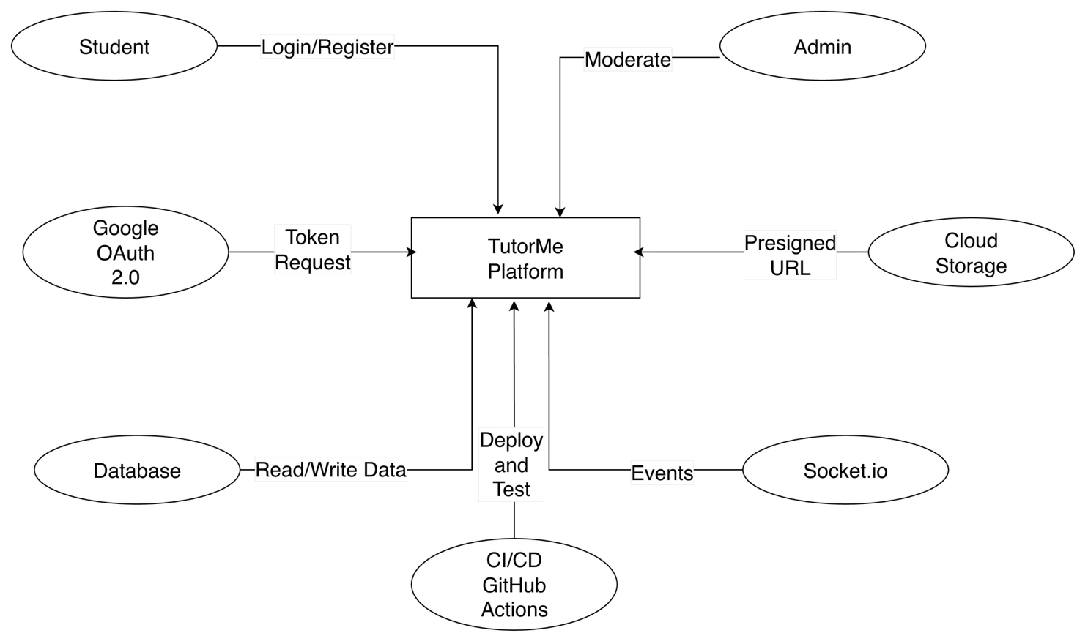
Figure 1: Context diagram for Peer Tutoring Platform
To start with, as it is shown above in Figure 1 the system context diagram illustrates the system boundary and the external entities that interact with the platform along with the data flows between them.
The central entity represents the platform itself which encompasses all core functionalities including authentication, content management, messaging, meeting scheduling, notifications and platform moderation.
There are sever external entities that interact with the system. The Student entity represents the primary user of the platform. Students send registration details, login credentials, post content, send messages, schedule meetings. In return the system provides the student with access to the feed, profile information, notifications and chat histories, meeting records.
In terms of the Administrator entity, it interacts with the system by reviewing reported content and performing moderation actions such as removing posts or freezing user accounts. The system provides access to platform statistics, user data and a dedicated dashboard.
In terms of Google OAuth 2.0, this entity serves as an external provider. Whenever a user chooses to authenticate through Google, the system sends a token verification request to the service which responds with the verified user identity.
The next entity is AWS S3* which is the external cloud storage service used in this project to store user uploaded files such as profile pictures and post images. The system requests a presigned URL and the client uses this URL to upload files directly to the storage bucket. The outcome is then stored in the database and served back to users.
In terms of the database entity, the system reads and writes all data to the database including user profiles, posts, messages, meetings, notifications and reports. The database returns query results in response to the requests.
Socket.io is an entity in the context diagram which is responsible for enabling live chatting between platform users. Whenever a message is sent, the system emits an event through this entity which broadcasts it to the connected recipient without requiring a page refresh.
Finally, GitHub Actions entity represents the CI/CD* pipeline connected to the system. The pipeline is responsible for running automated and integration tests on each push to the main branch. Upon successful completion the pipeline builds the frontend and deploys the updated application to a server.

Use Cases
This section presents the main use cases for this project. The use case diagram provides a high-level view of system interaction and the brief use cases describe the main flow of important system actions.

Use Case Diagram

Figure 2. Use Case Diagram of Peer Tutoring Platform

Use Cases Description

Name:
CRUD Post
Actors:
Tutor, Tutee
Precondition:
User is authenticated
Description:
This use case begins when a user wants to create a tutoring related post. The user enters a title, description and then submits the post. The system validates the input and stores the post in the database.
Postcondition:
New content has been added to the feed.

Name:
Send Friend Request
Actors:
Student
Precondition:
User is authenticated and viewing another user profile
Description:
This use case begins when a user selects another user and sends a peer request. The system records the request and updates the request status.
Postcondition:
The recipient receives a pending peer request notification.

Name:
Send Message
Actors:
Student
Precondition:
User is authenticated and has an active conversation
Description:
This use case begins when a user opens a conversation and sends a message. The system validates the message, stores it, and delivers it to the recipient in real time.
Postcondition:
The message is saved and displayed in the conversation history.

Name:
Schedule Meeting
Actors:
Student
Precondition:
Users are authenticated
Description:
This use case begins when a user proposes a tutoring meeting by entering a date, time, and session details. The system validates the meeting data and stores it.
Postcondition:
A meeting record is created and both users can view it.

Name:
Rate Session
Actors:
Student
Precondition:
A meeting has been completed
Description:
This use case begins when a user chooses to rate a completed tutoring session. The user selects a rating and submits it. The system validates that the user participated in the meeting and has not already rated it.
Postcondition:
The rating is stored and the relevant scores or points are updated.

Name:
Review Reports
Actors:
Administrator
Precondition:
Administrator is authenticated
Description:
This use case begins when an administrator reviews reported content. The administrator checks the report details and decides whether action is required.
Postcondition:
The report status is updated and, where necessary, content moderation action

Business Model Canvas

In this paragraph, the business model canvas and its features will be explored.

Business Model Canvas Diagram

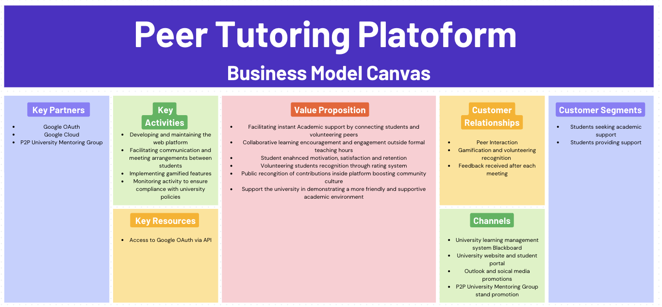

Figure 3. Business Model Canvas Diagram for Peer Tutoring Platform

Business Model Canvas Description
Key Partners:
- Google OAuth 2.0*
- Peer-to-Peer University Mentoring Group

Key Activities:
- Developing and maintaining the web platform
- Facilitating communication and meeting arrangements between students
- Implementing gamified features
- Monitoring activity to ensure compliance with university policies

Key Resources:
- Access to Google OAuth 2.0 via API*
- Web platform and source code
- MongoDB database
- AWS hosting infrastructure
- Developer and administrator time
- User community
Value Proposition:
- Facilitating instant academic support by connecting students and volunteering peers
- Collaborative learning encouragement and engagement outside formal teaching hours
- Student enhanced motivation, satisfaction and retention
- Volunteering students’ recognition through rating system
- Public recognition of contributions inside platform boosting community culture
- Support the university in demonstrating a more friendly and supportive academic environment
Customer Relationships:
- Peer to Peer Interaction
- Community support
- Gamification and volunteering recognition
- Feedback received after each meeting

Channels:
- University learning management system Blackboard
- University website and student portal
- Outlook and social media promotions
- Peer-to-Peer University Mentoring Group stand promotion

Customer Segments:
- Students seeking academic support
- Students providing support

Possible Risks
As Hennessy and Murphy (2025) highlighted, first-year university students often face barriers to engagement due to communication challenges, motivation, and access to timely academic support. These same factors present potential risks for the platform, particularly in keeping user participation and collaboration.
Technical risks include difficulties integrating Google Authentication. The platform may also encounter challenges in ensuring that all shared content remains accurate and appropriate.

Technologies Stack

Frontend:
- React.js

Backend:
- Node.js
- Express.js

Database:
- MongoDB

Authentication:
- Google OAuth
- JSON Web Token (JWT)*

Communication:
- Socket.io*

Success Metrics
The criteria the Peer Tutoring Platform must meet to be considered successful are outlined below.

Functional Metrics
- Users can register, log in and log out successfully.
- Users can create, edit and view profile information successfully.
- Users can create and view tutoring posts in the main feed.
- Users can like and comment on posts.
- Users can send, accept and reject friend requests and request state updates correctly.
- Users can send and receive messages.
- Users receive notifications for events such as comments, peer requests and meeting updates.
- Users can create and manage meeting records successfully.
- Users can rate completed tutoring meetings.
- Points are allocated correctly after eligible tutoring session.
- Administrators can review reports and moderate content.

Non-Functional Metrics
Security:
- Only authenticated users can access protected features.
- Passwords are stored securely using salted hashing.
- Unauthorized users cannot access administrator routes.

Usability:
- A user can log in, update a profile and create a post within 150 seconds without prior training.
- Users can navigate between the main screens without confusion.

Reliability:
- Messages, posts, profile data, meetings and ratings remain available after page refresh and normal reuse.
- The system maintains at least 95% uptime excluding scheduled maintenance.

Performance:
- The main feed loads within 5 seconds under normal conditions.
- Messages and notifications are delivered within 5 seconds during normal use.

Compatibility:
- The system operates correctly on Google Chrome.

Timeline
The timeline table below presents the key project milestones along with their scheduled start and completion dates. These timeframes may be adjusted if certain tasks require additional effort or take longer than anticipated.

Timeline Table

 | Oct. |  |  |  | Nov. |  |  |  | Dec. |  |  |  | Jan. |  |  |  | Feb. |  |  |  | Mar. |  |  |  | Apr.
Functional Specification
Research Document
Design Document
Post Use Case
Send Message Use Case
Send Peer Request Use Case
Schedule Meeting Use Case
Rate Service Use Case
Share Achievements Use Case
Search Users
Login/SignUp Use Cases
Functional Testing
Non-Functional Testing
Deployment
Final Report

Figure 4. Project Timeline Table

Inspiration

Lack of live academic question and answer system and peer tutoring platform may lead to university students suffering in silence, particularly when they require urgently clarification on challenging issues. Students may not know where they can ask questions, be afraid to email lecturers or simply feel afraid to request any assistance in front of the public, which overall may lead to lack of confidence and poor performance at school. This platform was also encouraged by other systems like Piazza (n.d.), which allows posting and answering of questions related to courses in a structured manner and Profi.ru (n.d.), which will be linked with the appropriate tutor depending on the needs of the learners. When these concepts are realized into a peer tutoring system that targets universities, students may post questions and receive knowledgeable peers within a short period of time and organise their support by messaging and scheduling. Consequently, academic assistance is made more accessible, there is less response time and the students are motivated to adopt positive help-seeking behaviour created by a friendly learning community.

Reference List

Byrd, S.C. (1990). The effects of peer tutoring on self-esteem and academic achievement. Journal of Educational Research, 84(2), pp. 98–102.
Bursuck, W.D. and Jayanthi, M. (1993). Academic and behavioral problems of students with learning disabilities. Journal of Learning Disabilities, 26(3), pp. 163–171.
Cardenas, J.A., Harris, M.B. and Graham, S. (1991). Peer tutoring: Effects on academic achievement, motivation, and attitudes toward school. Journal of Educational Psychology, 83(2), pp. 174–180.
Charlton, T. (1998). Peer tutoring: An introduction. Educational Psychology in Practice, 14(3), pp. 145–150.
Goodlad, S. and Hirst, B. (1990). Explorations in peer tutoring. Oxford: Blackwell.
Greenwald, A.G., Hedges, L.V. and Laine, R.D. (1996). The effect of school resources on student achievement. Review of Educational Research, 66(3), pp. 361–396.
Greenwood, C.R., Carta, J.J. and Hall, R.V. (1988). The use of peer tutoring strategies in classroom management and academic instruction. School Psychology Review, 17(2), pp. 258–275.
Hennessy, A. and Murphy, K. (2025). Barriers to student engagement: A focus group study on student engagement of first-year computing students. Irish Educational Studies, 44(1), pp. 183–200. https://doi.org/10.1080/03323315.2023.2256552
Karabenick, S.A. (2003). Seeking help in large college classes: A person-centered approach. Contemporary Educational Psychology, 28(1), pp. 37–58.
Krause, K. and Coates, H. (2008). Students’ engagement in first-year university. Assessment & Evaluation in Higher Education, 33(5), pp. 493–505. https://doi.org/10.1080/02602930701698892
Lazerson, D.B., Foster, M.A., Brown, R. and Horan, J.J. (1988). Peer tutoring and locus of control: Effects on academic performance. Psychology in the Schools, 25(1), pp. 20–26.
Piazza. (n.d.). Piazza: A question and answer platform for education. [online] Available: https://piazza.com [accessed 13 February 2026].
Podplota, P. (2022). Benefits of peer tutoring in higher education: A student perspective. Journal of Learning Development in Higher Education, (24), pp. 1–14.
Profi.ru (n.d.). Profi.ru: Online platform for finding tutors and specialists. [online] Available: https://profi.ru [accessed 13 February 2026].
Tinto, V. (2014). Reflective practice: Tinto’s South Africa lectures. Journal of Student Affairs in Africa, 2(2), pp. 5–28. https://doi.org/10.14426/jsaa.v2i2.66
Topping, K.J. (2001). Peer assisted learning: A practical guide for teachers. Educational Psychology in Practice, 17(3), pp. 231–240.
Topping, K.J. (2002). Peer and parent-assisted learning in reading. British Journal of Educational Psychology, 72(3), pp. 323–341. https://doi.org/10.1348/000709902320634016
Travis, J., Kaszycki, A., Geden, M. and Bunde, J. (2020). Some stress is good stress: The challenge-hindrance framework, academic self-efficacy, and academic outcomes. Journal of Educational Psychology, 112(8), pp. 1632–1647.

Glossary
Term Name | Term Description
API | Application Programming Interface. A defined interface through which the frontend communicates with backend services.
AWS S3 | Amazon Web Services Simple Storage Service. A cloud storage service used in this project for handling file uploads through presigned URLs
bcryptjs | A JavaScript library used in this project to hash user passwords during registration and verify submitted passwords securely during login.
CI/CD | Continuous Integration and Continuous Delivery/Deployment. In this project it refers to the automated GitHub Actions workflows used to run frontend and backend tests and support reliable deployment.
Express.js | A Node.js web framework used to define backend routes, middleware and API logic
MERN | MongoDB, Express.js, React.js and Node.js. The technology stack used to build the project.
MongoDB | A document oriented NoSQL database used to store system data.
Node.js | A JavaScript runtime environment used to execute backend application code.
Google OAuth 2.0 | An authenticated protocol used in the project for Google sign in
React.js | A JavaScript library used to build the frontend user interface.
REST API | An API style based on HTTP methods used for backend communication.
Socket.io | A library used to support live communication between connected users.

